The Foundery Classes

CNC Laser

Uses a CO2 laser and RDWorks: Version 8

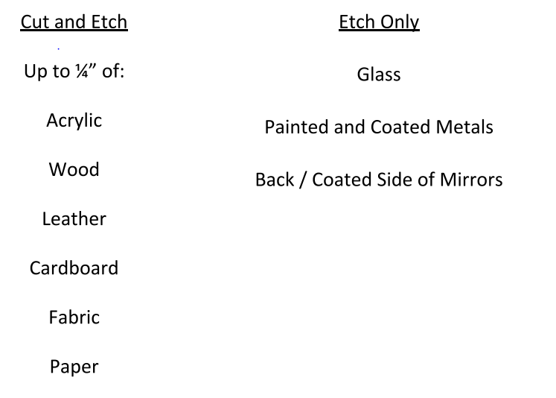

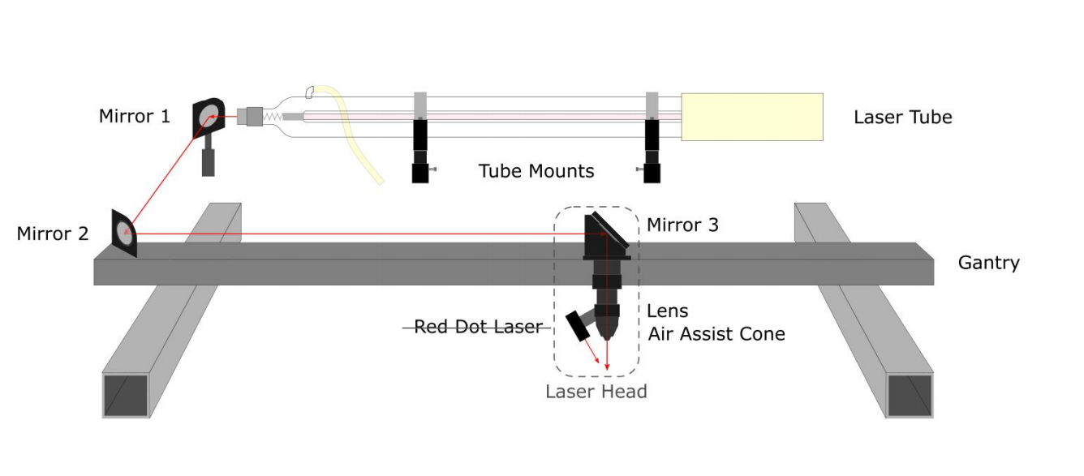

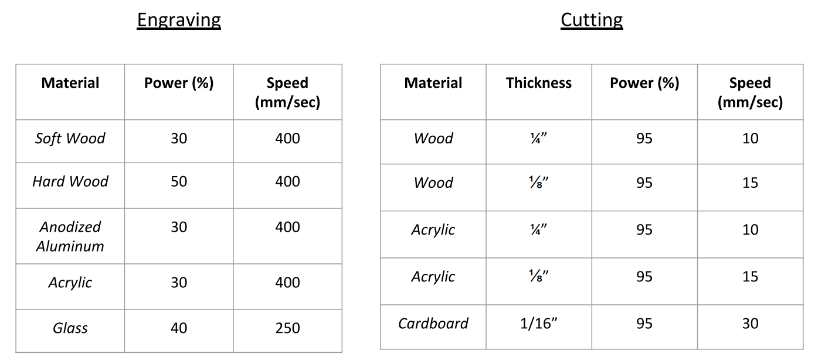

3D Printing

Uses an STL file which contains the part suitable for 3D printing.

The slicer creates Gcode for the different tool paths with each slice of the part, top to bottom

A glue stick can help with adhesion to the base plate.

Important to keep the atmosphere inside contained.

Infill controls how thick the part comes out. 100 percent infill is a solid piece inside and out

MIG Welding

MIG Welding melts two metals together with an electric arc that uses a constant filler being deposited onto the weld at a constant feed.

To weld two pieces together, a weave is used to ensure both metals are mixing over the weld.

To control heat, voltage is used. You can also control the feed of the filler per second.

TIG Welding – Steel and Stainless

There are inverters and Transformers. Transformers are more old school and more manual

DC electronegative is used most of the time. Thick line and dashed below it.

Tig torches are standard, but the series matters for parts needed.

DC is used for all materials but aluminum which uses AC

The shielding gas is Argon, which removes the oxygen to prevent oxidation and creates and inert atmosphere

The collet is the small metal piece that fits into the gas lens collet body.

The back cap puts pressure on the collet and tungsten electrode which goes through the collet, which is not a consumable.

Nozzle threads on gas lens collet body

A flush back cap lowers the clearance to reach tough to weld spots.

Grind the electrode to a 60 degree angle to create optimal arc.

Have electrode stick out around 1cm from nozzle tip

There are bands on tungsten which tell the characteristics of electrode.

The foot pedal initiates the arc. Max pedal is the max arc on the setting on machine. Post pedal keeps going to maintain inert atmosphere after weld. Hold till post weld is over and cherry weld cools. Can set the post flow time on machine

Parameters are recommended for type of material and thickness welding together

Types of joints:

1. Butt weld – both parts butted together, vertical weld position
2. Lap weld – to weld a part on top of another. 45 degree angle on part to create arc exactly in crease between the two metals.
3. T-joint – both metals make a perpendicular joint. 45 degree angle on part to create arc in the joint between the two metals.
4. Corner weld – Two parts touching edges, 45 degree angle in the crease of the two parts

20 cubic feet/ hour is a good flow rate for the argon

Filler characteristics:

ER 70s 6 – electrod rod, Tensile strength, silicone, 6?

Copper electrode used for mild steel.

308 for stainless, silver color

309 for steel and stainless same time.

Aluminum filler feels different, more bendy.

Acetone can clean steel before weld. Can also take wire brush to clean, steel brush for steel and stainless steel brush for stainless steel.

TIG Welding – Aluminum

Best filler rod is 4043

6061 is the best aluminum to weld. The higher thousand, the better.

Grind tungsten to a point then put a flat spot on point

Keep aluminum super clear pre weld

Aluminum forms layer of oxidation over time, takes time to melt it off.

To clean off, use alcohol, aluminum cleaner and stainless steel brush

When welding, watch for silvery puddle to form. Wait for that puddle to sink to a hole then push filler into it

Aluminum transfers heat faster then steel, so pedal will lessen as you weld through a part cause it is starting off hotter. Release fully near end of side

CNC Haas Mill – 3 Axis

Autodesk Fusion

Shell mill- used for facing

Settings top right, preferences, Solidworks

The nine square button, upload parts

CAM – computer aided manufacturing

Then, work left to right

FS wizard for all feeds and speeds

Face, tool path, clearance: bringing tool up for tool change

Retract: between tool paths

Feed: when it changes to actual feed ate

Top: start of stock/par

Bottom: start of part

Tool: feeds speeds

Geometry: Stock selection, part geometry

Heights: heights of motion of tool paths

Passes: pass mechanics for tool

Linking: Controls when tool not engaged

NYC CNC Youtube

CNC

Use height gage to zero machine

Power on

Estop pull

Reset x2

Open close door

Power up/restart

List prog,memory,scroll down, program 2020, select program, mem, cycle start white part, cancels, cycle start

Stainless steel unforgiving to work hardening

Grab tool 1, hold below flange, insert around below dry dogs, hold button, release when hear bsbsbs

Insert height gage in clamp, bring tool to the 4 in use jog to slow down

Tool offset measure, highlight H, geometry, -4. Dot is inch, write enter, y accept

Manual data input, MDI ----- for tool change

T2 type, ATC forwatf, repeat

LOCATE

CW, like manal mill, pull z, stop

OFFSET, G54 select, highline axis, part zero, account for radius! Joy, part zero set

SHUT DOWN

Power, estop, close monitor, switch in back, close breaker